Installation Guide :

1. Download the file from the link

https://github.com/kracr/ontoseer/releases

2. Click on Ontoseer.jar
The jar file will get downloaded.

3.Copy the jar file in the plugins folder of Protege.

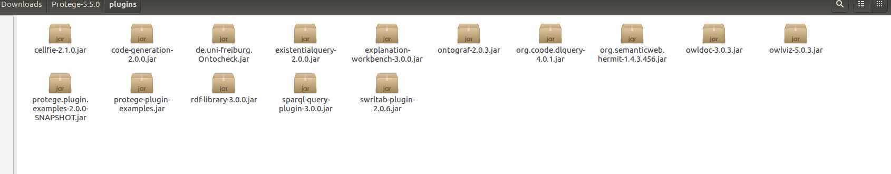
4. Restart Protege.

5. Go to about Section of Protege and check whether the plugin has been correctly installed or not .It will be shown in the window.

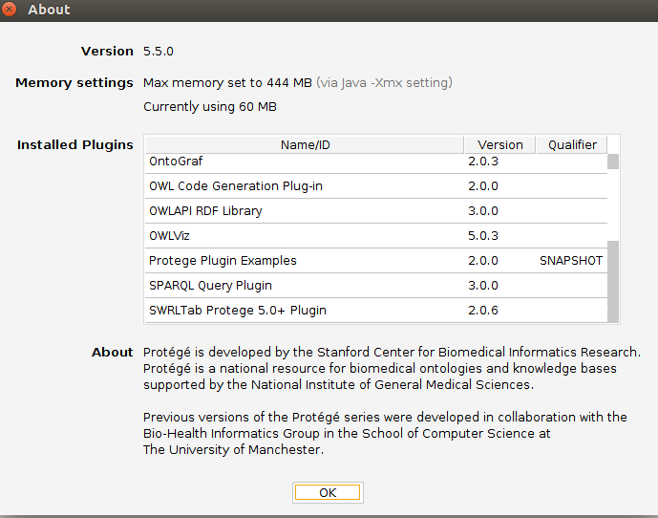

6 .

Click on Windows.
Click on Tabs .
Click on Example Tab.

This window will appear.

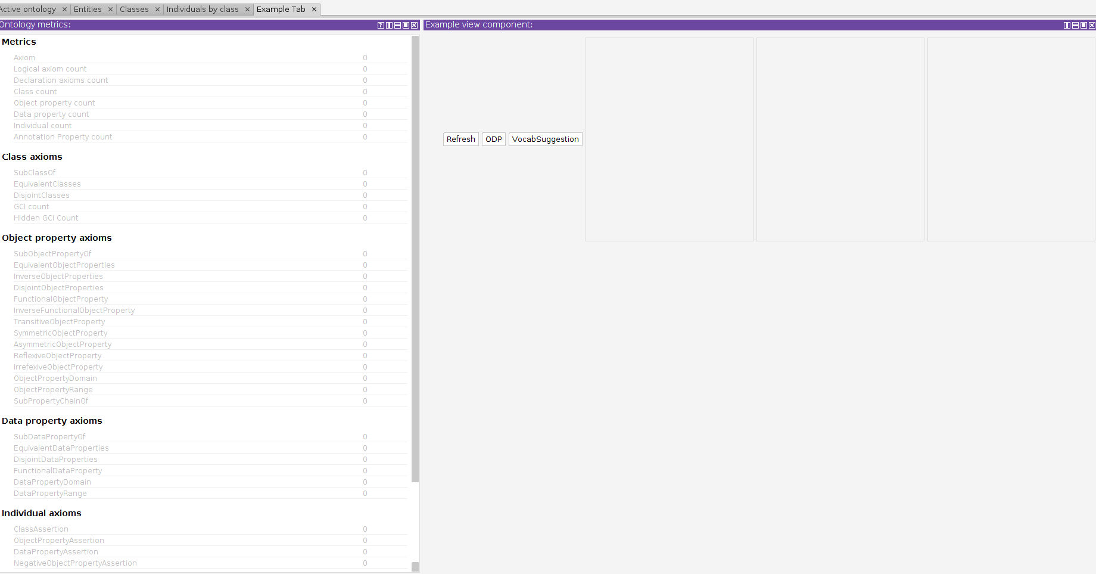

Now Start Building your Ontology.

